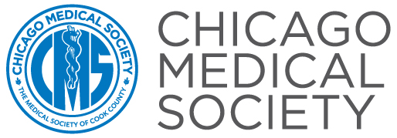 | Presents: ICD-10-CM: Preparing for a Successful Implementation



Presented by: Nelly Leon-Chisen, RHIA, Director, Coding and Classification,
American Hospital Association, Chicago, IL

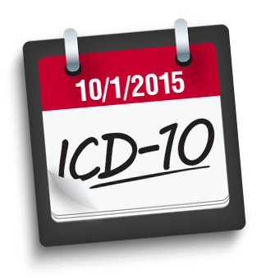
Ms. Leon-Chisen had disclosed that she does not have any relevant financial relationships with commercial interests.

2015 Schedule Implement Deadline:

Thursday, July 9- Chicago Medical Society Building 9:00AM-12:30pm
33 W. Grand 2nd FL, Chicago, IL 60654

Target Audience: All Physicians, Practice Managers, Physician Executive Staff and Medical Office Staff
Desired Learning Outcomes: At the completion of this learning activity, participants should be able to:
- Describe key elements required in a plan for a successful transition to ICD-10-CM.
- Make recommendations for each of the four phases of implementation of ICD-10: Planning, impact analysis, implementation, and post-implementation.
- Discuss the code structure, format and basic conventions of ICD-10-CM diagnosis coding and understands its impact.

The Chicago Medical Society is accredited by the Accreditation Council for Continuing Medical Education (ACCME) to provide continuing medical education for physicians. The Chicago Medical Society designates this live activity for a maximum of 3.5 AMA PRA Category 1 Credit (s)™. Physicians should claim only the credit commensurate with the extent of their participation in the activity.

The following planning members of the Chicago Medical Society’s CME Committee have disclosed that they do not have any relevant financial relationships with commercial interests: Ajay K. Chauhan, MD, Chairman, Howard Axe, MD, Vickie L. Becker, MD, Adrienne L. Fregia, MD, Robert W. Panton, MD, Loren S. Schechter, MD, Kathy M. Tynus, MD, Kenneth Busch, MD, Course Director, and Haydee Nascimento, Director of Education.

Registration Form for: ◻ 7/9 |  | Method of Payment:

 |  |  |  |  |  |  | ◻ Check enclosed in the amount of |  |  |  | $
Fee: ◻ CMS Mbr: $59 ◻ Non-Mbr: $159 |  |  |  |  |  |  | ◻ Charge: | $ |  | ◻ Visa ◻ Master Card ◻ Amex
Attendee Name: |  |  |  |  |  |  | Account #:
Mailing/Billing Address: |  |  |  |  |  |  | Exp. Date:
EMAIL (required): |  |  |  |  |  |  | Signature:
Phone:

Registration: Send your 2015 ICD-10 registrations to:
Mail to: Chicago Medical Society - Attn: Education Dept.
515 N. Dearborn St., Chicago, IL 60654
Register Online: www.cmsdocs.org Fax: 312-670-3646
To be removed from our fax program, please return this fax with the words “Remove Me” and include your name and fax number or email The Chicago Medical Society at cms@cmsdocs.org with your name and fax number. Thank you.

